Machine learning Lab Observation
ITA0614
Experiment 3
Demonstrate the working of the decision tree based ID3 algorithm. Use an appropriate data set for building the decision tree and apply this knowledge to classify a new sample.
Name : Sakthi K S
Reg.No : 192412247
Problem 1: Employee Promotion Prediction
Aim
To implement the ID3 algorithm on employee performance data, build a decision tree using information gain and classify whether a new employee will be promoted.
Algorithm
1. Create the root node for the decision tree using the training examples and available attributes.
2. If all training examples belong to the same class, make that class a leaf. If no attributes remain, use the majority class.
3. Calculate Entropy(S) = −Σ p log₂p and Information Gain for every available attribute.
4. Select the attribute with the highest information gain as the decision node.
5. Create branches for each value of the selected attribute and recursively build the remaining subtrees.
6. For a new sample, follow the matching branches from the root until a leaf is reached and report its class.
Program:
# ID3 decision tree – Employee Promotion Prediction
import pandas as pd
from math import log2
from collections import Counter

data = [['Excellent', 'High', 'Completed', 'Good', 'Yes'], ['Excellent', 'Low', 'Completed', 'Good', 'Yes'], ['Average', 'High', 'Completed', 'Good', 'Yes'], ['Poor', 'Low', 'Not Completed', 'Poor', 'No'], ['Average', 'Low', 'Completed', 'Average', 'No'], ['Excellent', 'High', 'Not Completed', 'Good', 'Yes'], ['Poor', 'High', 'Not Completed', 'Poor', 'No'], ['Average', 'High', 'Not Completed', 'Average', 'No']]
columns = ['Performance', 'Experience', 'Training', 'Attendance', 'Promotion']
df = pd.DataFrame(data, columns=columns)

def entropy(values):
counts = Counter(values)
n = len(values)
return -sum((c/n) * log2(c/n) for c in counts.values())

def information_gain(df, attribute, target):
total = entropy(df[target])
weighted = 0
for _, group in df.groupby(attribute):
weighted += len(group)/len(df) * entropy(group[target])
return total - weighted

for attribute in columns[:-1]:
print(attribute, round(information_gain(df, attribute, columns[-1]), 3))

# Build the ID3 tree using the attribute with highest information gain.
# Classify the new sample using the learned tree.
Input
Training data set:
Performance | Experience | Training | Attendance | Promotion
Excellent | High | Completed | Good | Yes
Excellent | Low | Completed | Good | Yes
Average | High | Completed | Good | Yes
Poor | Low | Not Completed | Poor | No
Average | Low | Completed | Average | No
Excellent | High | Not Completed | Good | Yes
Poor | High | Not Completed | Poor | No
Average | High | Not Completed | Average | No

New sample: ('Excellent', 'Low', 'Completed', 'Average')
Output
Entropy of the data set = 1.000
Gain(Performance) = 0.656
Gain(Experience) = 0.049
Gain(Training) = 0.189
Gain(Attendance) = 1.000
Decision tree root = Attendance
New sample: ('Excellent', 'Low', 'Completed', 'Average')
Prediction: Promotion = Yes
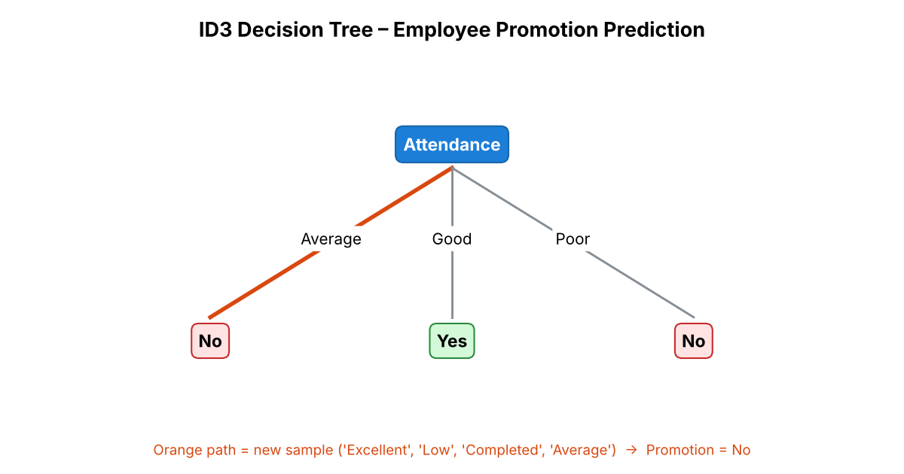
Result
The ID3 algorithm was applied successfully. Attendance has the highest information gain (1.000) and is selected as the root of the decision tree. The new sample ('Excellent', 'Low', 'Completed', 'Average') is classified as Yes.
Problem 2: Car Purchase Decision
Aim
To apply the ID3 algorithm to customer information, construct a decision tree using information gain and predict whether a new customer will purchase a car.
Algorithm
1. Create the root node for the decision tree using the training examples and available attributes.
2. If all training examples belong to the same class, make that class a leaf. If no attributes remain, use the majority class.
3. Calculate Entropy(S) = −Σ p log₂p and Information Gain for every available attribute.
4. Select the attribute with the highest information gain as the decision node.
5. Create branches for each value of the selected attribute and recursively build the remaining subtrees.
6. For a new sample, follow the matching branches from the root until a leaf is reached and report its class.
Program:
# ID3 decision tree – Car Purchase Decision
import pandas as pd
from math import log2
from collections import Counter

data = [['High', 'Young', 'Small', 'Private', 'No'], ['High', 'Middle', 'Large', 'Government', 'Yes'], ['Medium', 'Middle', 'Large', 'Private', 'Yes'], ['Low', 'Young', 'Small', 'Private', 'No'], ['Medium', 'Young', 'Large', 'Government', 'Yes'], ['Low', 'Middle', 'Small', 'Government', 'No'], ['High', 'Old', 'Large', 'Private', 'Yes'], ['Medium', 'Old', 'Small', 'Private', 'No']]
columns = ['Income', 'AgeGroup', 'Family', 'Job', 'Purchase']
df = pd.DataFrame(data, columns=columns)

def entropy(values):
counts = Counter(values)
n = len(values)
return -sum((c/n) * log2(c/n) for c in counts.values())

def information_gain(df, attribute, target):
total = entropy(df[target])
weighted = 0
for _, group in df.groupby(attribute):
weighted += len(group)/len(df) * entropy(group[target])
return total - weighted

for attribute in columns[:-1]:
print(attribute, round(information_gain(df, attribute, columns[-1]), 3))

# Build the ID3 tree using the attribute with highest information gain.
# Classify the new sample using the learned tree.
Input
Training data set:
Income | AgeGroup | Family | Job | Purchase
High | Young | Small | Private | No
High | Middle | Large | Government | Yes
Medium | Middle | Large | Private | Yes
Low | Young | Small | Private | No
Medium | Young | Large | Government | Yes
Low | Middle | Small | Government | No
High | Old | Large | Private | Yes
Medium | Old | Small | Private | No

New sample: ('Medium', 'Young', 'Small', 'Government')
Output
Entropy of the data set = 1.000
Gain(Income) = 0.311
Gain(AgeGroup) = 0.061
Gain(Family) = 1.000
Gain(Job) = 0.049
Decision tree root = Family
New sample: ('Medium', 'Young', 'Small', 'Government')
Prediction: Purchase = Yes
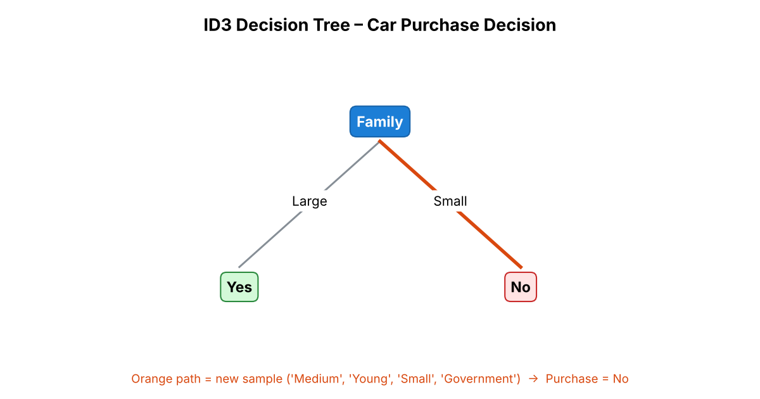
Result
The ID3 algorithm was applied successfully. Family has the highest information gain (1.000) and is selected as the root of the decision tree. The new sample ('Medium', 'Young', 'Small', 'Government') is classified as Yes.
Problem 3: Crop Disease Detection
Aim
To implement ID3 for crop disease detection, construct a decision tree from crop and leaf conditions and classify a new crop sample as Healthy or Diseased.
Algorithm
1. Create the root node for the decision tree using the training examples and available attributes.
2. If all training examples belong to the same class, make that class a leaf. If no attributes remain, use the majority class.
3. Calculate Entropy(S) = −Σ p log₂p and Information Gain for every available attribute.
4. Select the attribute with the highest information gain as the decision node.
5. Create branches for each value of the selected attribute and recursively build the remaining subtrees.
6. For a new sample, follow the matching branches from the root until a leaf is reached and report its class.
Program:
# ID3 decision tree – Crop Disease Detection
import pandas as pd
from math import log2
from collections import Counter

data = [['Green', 'Absent', 'Normal', 'Good', 'Healthy'], ['Yellow', 'Present', 'High', 'Poor', 'Diseased'], ['Green', 'Present', 'High', 'Poor', 'Diseased'], ['Yellow', 'Present', 'Normal', 'Poor', 'Diseased'], ['Green', 'Absent', 'High', 'Good', 'Healthy'], ['Green', 'Absent', 'Normal', 'Average', 'Healthy'], ['Yellow', 'Absent', 'High', 'Average', 'Healthy'], ['Green', 'Present', 'Normal', 'Good', 'Diseased']]
columns = ['LeafColor', 'Spots', 'Moisture', 'Growth', 'Disease']
df = pd.DataFrame(data, columns=columns)

def entropy(values):
counts = Counter(values)
n = len(values)
return -sum((c/n) * log2(c/n) for c in counts.values())

def information_gain(df, attribute, target):
total = entropy(df[target])
weighted = 0
for _, group in df.groupby(attribute):
weighted += len(group)/len(df) * entropy(group[target])
return total - weighted

for attribute in columns[:-1]:
print(attribute, round(information_gain(df, attribute, columns[-1]), 3))

# Build the ID3 tree using the attribute with highest information gain.
# Classify the new sample using the learned tree.
Input
Training data set:
LeafColor | Spots | Moisture | Growth | Disease
Green | Absent | Normal | Good | Healthy
Yellow | Present | High | Poor | Diseased
Green | Present | High | Poor | Diseased
Yellow | Present | Normal | Poor | Diseased
Green | Absent | High | Good | Healthy
Green | Absent | Normal | Average | Healthy
Yellow | Absent | High | Average | Healthy
Green | Present | Normal | Good | Diseased

New sample: ('Green', 'Absent', 'High', 'Average')
Output
Entropy of the data set = 1.000
Gain(LeafColor) = 0.049
Gain(Spots) = 1.000
Gain(Moisture) = 0.000
Gain(Growth) = 0.656
Decision tree root = Spots
New sample: ('Green', 'Absent', 'High', 'Average')
Prediction: Disease = Healthy
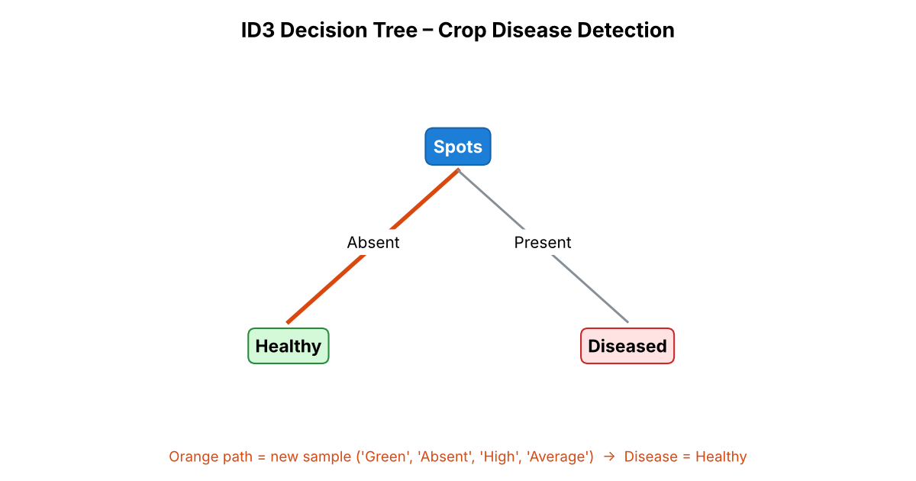
Result
The ID3 algorithm was applied successfully. Spots has the highest information gain (1.000) and is selected as the root of the decision tree. The new sample ('Green', 'Absent', 'High', 'Average') is classified as Healthy.
Problem 4: Email Spam Detection
Aim
To demonstrate the ID3 algorithm for email classification, construct a decision tree from email characteristics and predict whether a new email is Spam or Not Spam.
Algorithm
1. Create the root node for the decision tree using the training examples and available attributes.
2. If all training examples belong to the same class, make that class a leaf. If no attributes remain, use the majority class.
3. Calculate Entropy(S) = −Σ p log₂p and Information Gain for every available attribute.
4. Select the attribute with the highest information gain as the decision node.
5. Create branches for each value of the selected attribute and recursively build the remaining subtrees.
6. For a new sample, follow the matching branches from the root until a leaf is reached and report its class.
Program:
# ID3 decision tree – Email Spam Detection
import pandas as pd
from math import log2
from collections import Counter

data = [['Yes', 'Yes', 'Yes', 'No', 'Spam'], ['Yes', 'Yes', 'No', 'Yes', 'Spam'], ['No', 'Yes', 'No', 'No', 'Not Spam'], ['No', 'No', 'No', 'No', 'Not Spam'], ['Yes', 'No', 'Yes', 'Yes', 'Spam'], ['No', 'Yes', 'Yes', 'No', 'Spam'], ['No', 'No', 'Yes', 'No', 'Not Spam'], ['Yes', 'No', 'No', 'No', 'Not Spam']]
columns = ['UnknownSender', 'HasLink', 'UrgentWords', 'Attachment', 'Class']
df = pd.DataFrame(data, columns=columns)

def entropy(values):
counts = Counter(values)
n = len(values)
return -sum((c/n) * log2(c/n) for c in counts.values())

def information_gain(df, attribute, target):
total = entropy(df[target])
weighted = 0
for _, group in df.groupby(attribute):
weighted += len(group)/len(df) * entropy(group[target])
return total - weighted

for attribute in columns[:-1]:
print(attribute, round(information_gain(df, attribute, columns[-1]), 3))

# Build the ID3 tree using the attribute with highest information gain.
# Classify the new sample using the learned tree.
Input
Training data set:
UnknownSender | HasLink | UrgentWords | Attachment | Class
Yes | Yes | Yes | No | Spam
Yes | Yes | No | Yes | Spam
No | Yes | No | No | Not Spam
No | No | No | No | Not Spam
Yes | No | Yes | Yes | Spam
No | Yes | Yes | No | Spam
No | No | Yes | No | Not Spam
Yes | No | No | No | Not Spam

New sample: ('No', 'Yes', 'No', 'No')
Output
Entropy of the data set = 1.000
Gain(UnknownSender) = 0.189
Gain(HasLink) = 0.189
Gain(UrgentWords) = 0.189
Gain(Attachment) = 0.311
Decision tree root = Attachment
New sample: ('No', 'Yes', 'No', 'No')
Prediction: Class = Not Spam
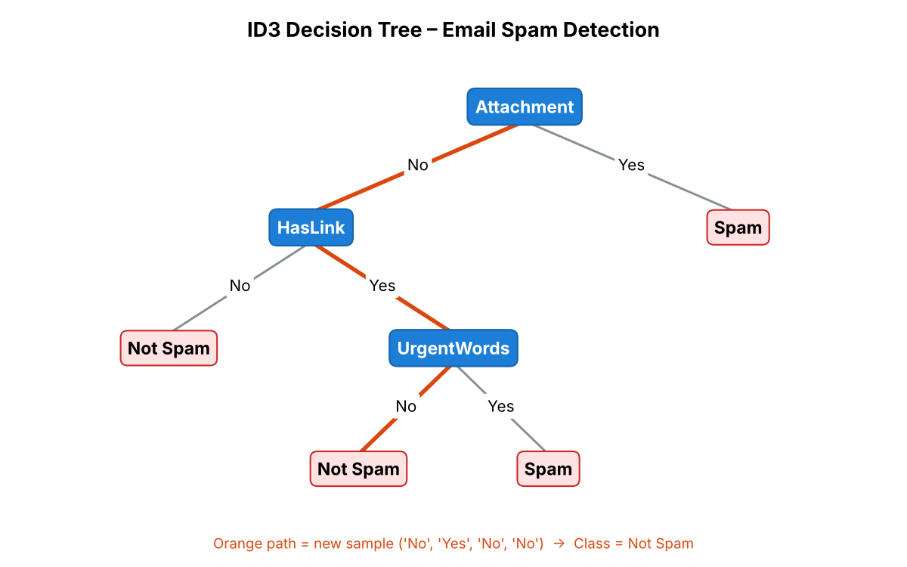
Result
The ID3 algorithm was applied successfully. Attachment has the highest information gain (0.311) and is selected as the root of the decision tree. The new sample ('No', 'Yes', 'No', 'No') is classified as Not Spam.
Problem 5: House Rent Prediction
Aim
To use the ID3 algorithm for house rent classification, build a decision tree from house features and predict the rent category for a new house.
Algorithm
1. Create the root node for the decision tree using the training examples and available attributes.
2. If all training examples belong to the same class, make that class a leaf. If no attributes remain, use the majority class.
3. Calculate Entropy(S) = −Σ p log₂p and Information Gain for every available attribute.
4. Select the attribute with the highest information gain as the decision node.
5. Create branches for each value of the selected attribute and recursively build the remaining subtrees.
6. For a new sample, follow the matching branches from the root until a leaf is reached and report its class.
Program:
# ID3 decision tree – House Rent Prediction
import pandas as pd
from math import log2
from collections import Counter

data = [['Prime', 'Large', 'Yes', 'New', 'High'], ['Prime', 'Large', 'No', 'New', 'High'], ['Prime', 'Small', 'Yes', 'Old', 'High'], ['Normal', 'Large', 'Yes', 'New', 'High'], ['Normal', 'Small', 'No', 'Old', 'Low'], ['Normal', 'Small', 'Yes', 'Old', 'Low'], ['Far', 'Large', 'No', 'Old', 'Low'], ['Far', 'Small', 'Yes', 'New', 'Low']]
columns = ['Location', 'Size', 'Furnished', 'Age', 'Rent']
df = pd.DataFrame(data, columns=columns)

def entropy(values):
counts = Counter(values)
n = len(values)
return -sum((c/n) * log2(c/n) for c in counts.values())

def information_gain(df, attribute, target):
total = entropy(df[target])
weighted = 0
for _, group in df.groupby(attribute):
weighted += len(group)/len(df) * entropy(group[target])
return total - weighted

for attribute in columns[:-1]:
print(attribute, round(information_gain(df, attribute, columns[-1]), 3))

# Build the ID3 tree using the attribute with highest information gain.
# Classify the new sample using the learned tree.
Input
Training data set:
Location | Size | Furnished | Age | Rent
Prime | Large | Yes | New | High
Prime | Large | No | New | High
Prime | Small | Yes | Old | High
Normal | Large | Yes | New | High
Normal | Small | No | Old | Low
Normal | Small | Yes | Old | Low
Far | Large | No | Old | Low
Far | Small | Yes | New | Low

New sample: ('Normal', 'Large', 'No', 'New')
Output
Entropy of the data set = 1.000
Gain(Location) = 0.656
Gain(Size) = 0.189
Gain(Furnished) = 0.049
Gain(Age) = 0.189
Decision tree root = Location
New sample: ('Normal', 'Large', 'No', 'New')
Prediction: Rent = High
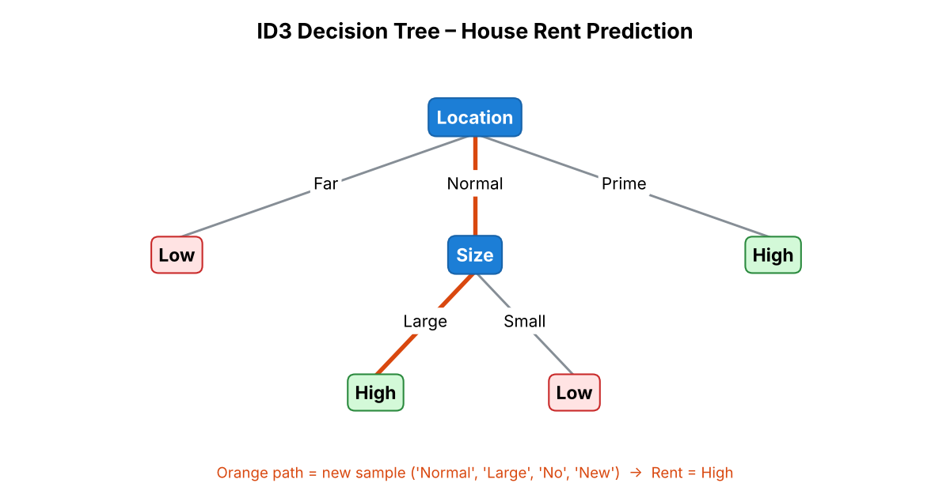
Result
The ID3 algorithm was applied successfully. Location has the highest information gain (0.656) and is selected as the root of the decision tree. The new sample ('Normal', 'Large', 'No', 'New') is classified as High.

